Thermostats

Thermostats are devices which measure the temperature of the physical system and act accordingly to maintain the required set temperature. They operate as a closed-loop control device. They are most commonly used in central heating system, air conditioners, refrigerators, HVAC (Heating Ventilation Air Conditioning) system, water heaters, ovens, car engine management and in scientific equipment like incubators etc.

# Type 1

## ANALOG MECHANICAL THERMISTOR

 This thermistor you are seeing here is ***Bimetallic strip*** based (a strip which increases/decreases its size by increase /decrease in temperature).

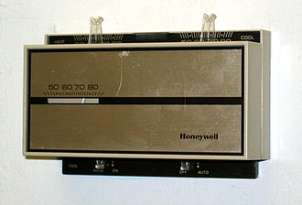

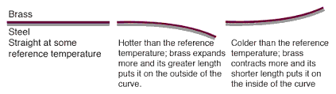

* In the above picture the Bimetallic Strip Principle is explained.
* The above-mentioned thermistor can sense temperature and can maintain set temperature but can't do anything else.
* It doesn't have any network connectivity and programmability, so it is a not IoT device with nearly no computational ability.

# Type 2

## DIGITAL THERMOSTAT

This is a next-generation digital thermistor which uses relay or semiconductor device such as ***Triac*** to control HVAC unit.

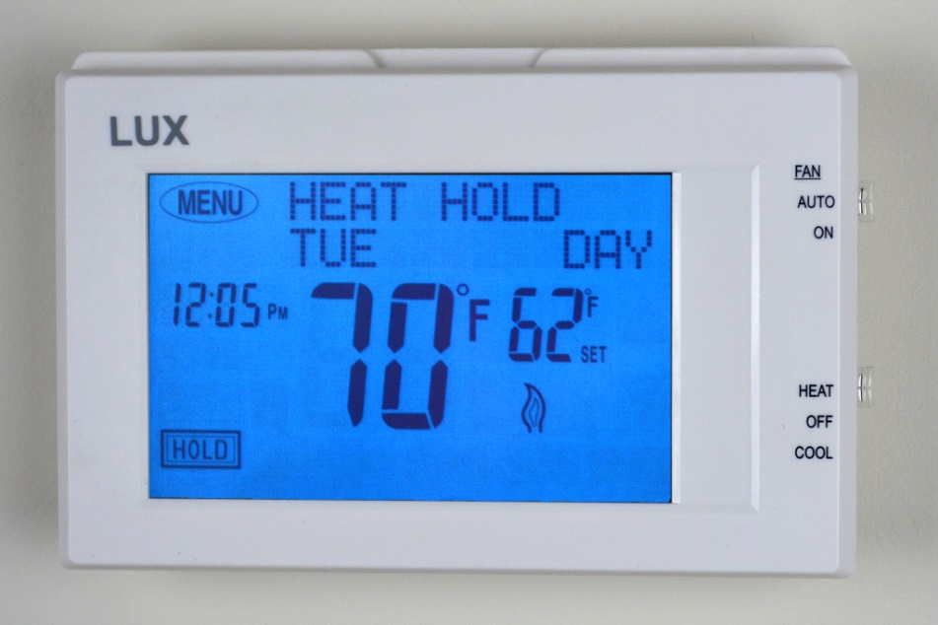

* It has a digital display, touch screen input, some computational ability like setting various parameters like time-based temperature control, fan control, etc.
* We can also set modes according to time in it.
* It also has a basic clock, so it displays time and date to give us a quick glimpse
* It has a lot more features than type 1 Thermostat.
* It is smarter than type 1, but this is also a non IoT device as it doesn't have any network connectivity.

# Type 3

## NEST LEARNING THERMOSTAT

This is nest learning thermostat which is one of the smartest thermostats available. It offers a whole new range of features than type 1 and type 2 thermostats.

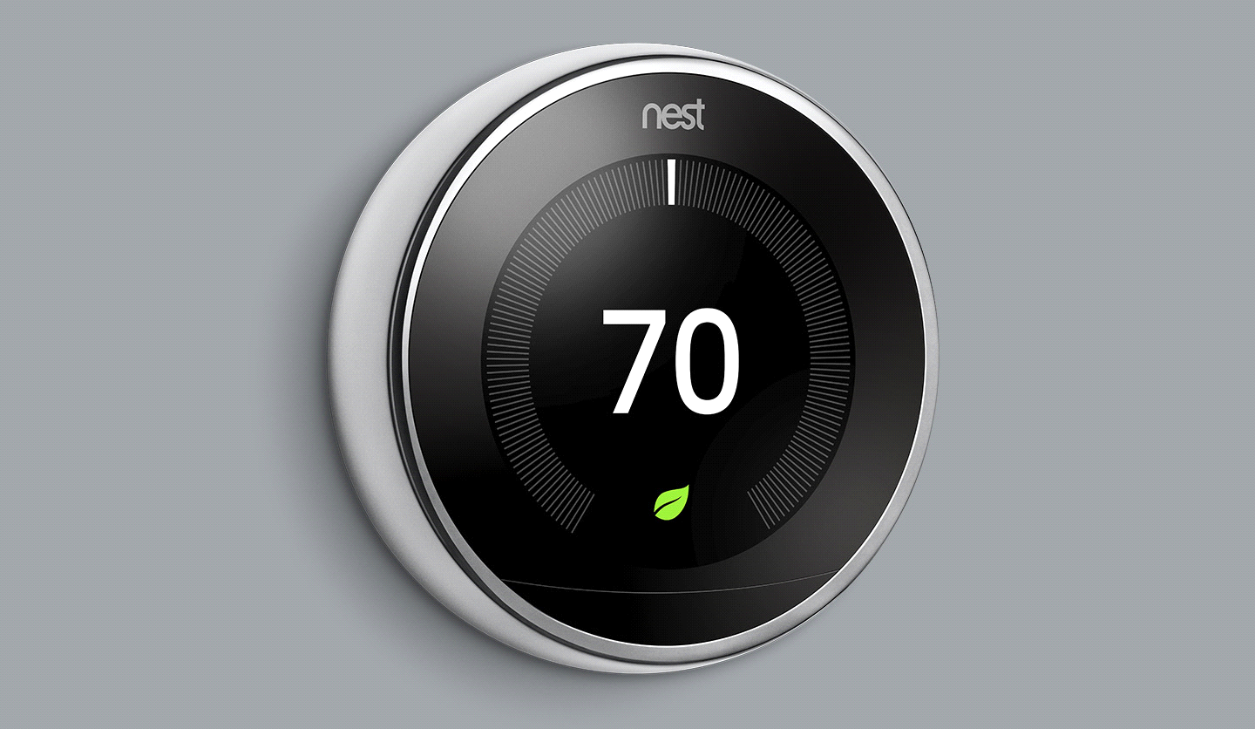

* It is a thermostat that can connect to the internet. you can access this using the nest app on your smartphone.
* It has machine learning-based computational ability which analyses your preferences in the first two weeks and maintains HVAC units according to that.
* It also analyses the weather using the internet and tunes your HVAC unit according to that data.
* you can always change settings by phone.
* It also changes the parameters like temperature setting based on seasons.
* It smartly senses whether rooms are occupied or not and controls HVAC units and reduces power consumption.
* According to some surveys this thermostat saves around 40% of electricity daily by its smart technology.
* This is an IoT device as it has internet connectivity, computational ability dedicated to a specific task.
* This can also interconnect with other IoT devices and provide us a great experience.
* Here we can observe that, by adding the concept of IoT to a simple thermistor we increase its features dramatically which indeed makes our lives easier.

# Risks

* It can receive wrong data about weather from the internet due to location problem or other issue and can increase consumption of electricity.
* Without security protocols, it can be vulnerable to cyber attacks in which it can act as an access point to control other devices like security camera, etc.
* Over dependence on technology